

Symptoms:
- If in heart arteries
  - Angina
  - Shortness of breath
  - Problems with heart rate or rhythm
- If in brain arteries
  - Sudden weakness
  - Paralysis
  - Confusion
  - Dizziness
  - Problems breathing
- If in arm or leg arteries
  - Numbness
  - Pain
  - Infections
- If in kidney arteries
  - Tiredness
  - Urination more or less often
  - Swelling in hands or feet
  - Itchiness or numbness
- Follow the DASH, Mediterranean, or AHA diets
  - High intake of:
    - Vegetables
    - Fruit
    - Whole Grains
    - Non-Red Meat Protein
  - Low intake of:
    - Sweets
    - Sugary Beverages
    - Red Meats
- 150-300 minutes of physical activity
- Weigh regularly
- Lose weight gradually
- Keep a food journal
- People over the age of 65
- Males develop this quicker than females
- Females that have reached menopause
- Obesity with a BMI of 30 or greater
- Having the following disease:
  - Hypertension
  - Dyslipidemia
  - Diabetes Mellitus
  - Metabolic Syndrome
  - High Blood Pressure
- Family history of heart disease
- Unhealthy diet
- Physical inactivity
- Smoking
Information Technology Solutions

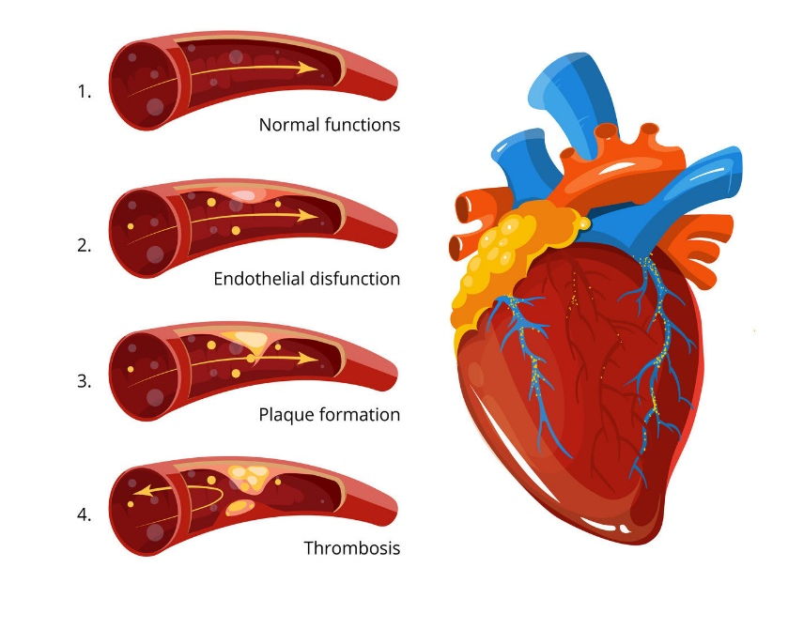
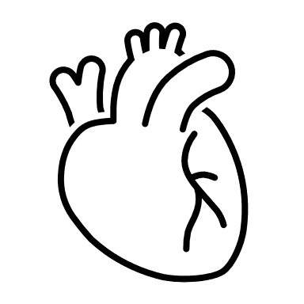
Image adapted from Atherosclerosis, blood clot formation. Vector medical illustration By Microvector | TheHungryJPEG.com
Atherosclerosis
The buildup of plaque on the inner walls of arteries which causes them to become narrow and hard.
- A small tear on the inner wall of an artery caused by high blood pressure, diabetes, or blood clotting medications.
- The body tries to fix the tear by gathering and clumping blood cells and other substances causing a buildup in the arteries lining.
- This causes plaque to develop and harden which causes a narrowing of the artery and blood is not able to flow properly.

What is it?
How do I fix/prevent it?
Who is at Risk?

References:
Atherosclerosis. (n.d.). Retrieved February 28, 2021, from https://www.nhlbi.nih.gov/health-topics/atherosclerosis
The Mayo Clinic Staff. (2018, April 24). Arteriosclerosis / atherosclerosis. Retrieved February 28, 2021, from https://www.mayoclinic.org/diseases-conditions/arteriosclerosis-atherosclerosis/symptoms-causes/syc-20350569
Nahikian-Nelms, M., Sucher, K., Roberts, K., Estes Doetsch, H., Rusnak, S., Sergakis, G., Hansen-Petrik, M., Heuberger, R. A. (2020). Nutrition Therapy and Pathophysiology (Fourth ed., pp. 312-317). Boston, MA: Cengage.

