Written Project: Maple Syrup Urine Disease (MSUD)
Chanley Ferguson
University of Houston

Maple Syrup Urine Disease is a very rare yet serious macronutrient disease. It is an autosomal recessive inherited condition which effects homozygous individuals and individuals that are heterozygous are asymptomatic but are carriers of the genetic mutation. It effects one in 185,000 of people worldwide with 3,400 to 4,100 patients in the world and 800 to 1,000 patients in the United States (Baylor).
Maple Syrup Urine Disease is caused by a deficiency of branched-chain a-ketoacid dehydrogenase (BCKAD). MSUD impairs the function of BCKD to break down three branched-chain amino acids Valine, Isoleucine, and Leucine (VIC) and there branched-chain a-ketoacids. These are considered essential amino acids that can only be obtained in our diet. Due to this dysfunction in branching amino acid metabolism, there is an increase in concentration of VIC. The increase causes an inhibition of the uptake and transport of other large amino acids into the brain such as tyrosine and tryptophan. When the brain receives a reduced uptake of these large amino acids, there is a decrease of dopamine and serotonin synthesis. The reason the disease is called Maple Syrup Urine Disease is because isoleucine is converted into alloisoleucine in the body, which is a sure sign of MSUD, and both isoleucine and alloisoleucine can be converted to sotolone which is molecule that creates a sweet maple syrup smell in urine and feces.
There are two main types of MSUD Classic and Intermediate. During Classic MSUD there is little to no functional complexes. This form appears within 48 hours of birth and symptoms include ketonuria, irritability, poor feeding, lethargy, and opisthotonos. If this form is not treated within seven to ten days, the baby can develop cerebral edema, seizures, coma, and respiratory failure which can result in death. Intermediate MSUD is where about 5-8% of the complexes are functional. This form shows up later in life and at irregular intervals. It is triggered by metabolic stressors such as heavy exercise, infection, and fasting which causes the body to break down its own proteins. Symptoms of this form include the urine and earwax smelling of maple syrup, feeding problems, and delayed growth and cerebral development.
Diagnosis of Maple Syrup Urine Disease are concluded by clinical symptoms and running a series of labs of the urine and blood. The blood will be tested for elevated levels of the amino acids valine, leucine, isoleucine, and alloisoleucine. The urine will be tested for byproducts of the amino acids. Treatment for MSUD include a restricted low-protein diet and, in severe cases, hemodialysis can be conducted to remove excess amino acids from the blood. The only cure is a liver transplant where the new hepatocytes have normal levels of BCKD complexes, but this is rarely done.
There was also a recent study that was completed back in 2017 by Brandan Lee at Baylor College of Medicine in Houston Texas. They tested the drug phenylbutyrate and it was shown to reduce the amounts of the amino acids VIC and their byproducts in the bloodstream. They conducted a 20 healthy and MSUD participants and gave half the actual drug and the other half a fake drug four times a day over the period of two weeks.

My patient is a 2-day old male baby with Maple Syrup Urine Disease, and I am conveying to his parents about his disease. Maple Syrup Urine Disease is an autosomal recessive disease which means that both mom and dad carry the trait for the disease and pass it on to their homozygous baby. If the baby is heterozygous, they will carry the trait but will not show symptoms. This disease is pretty rare, it effects 1 in 187,000 people in the world and 800 to 1,000 people in the United States.
The reason it is called Maple Syrup Urine Disease is because the amino acid isoleucine can be broken down to create the molecule that gives caramel and maple syrup its sweet smell which causes the urine to smell like maple syrup. Essential amino acids that are compromised in your son’s body due to his condition. Essential means that we cannot create the amino acids ourselves, so we have to get them from food that are high in protein. Examples of this are eggs, meat, dairy, avocados, and beans. When you eat these protein rich foods, they are broken down by our stomachs to create amino acids. They are absorbed by the blood stream in the small intestine and travel to our cells for protein synthesis. Our bodies cannot keep extra amino acids so they are turned into sugar and ketones for energy. So, since your son has MSUD, three of these essential amino acids valine, leucine, and isoleucine (we will call these VIC) cannot be fully broken down. MSUD causes the second step of the brake down to malfunction due to mutations in alleles. This causes an increase of amino acids and their byproducts.
There are two types of MSUD which are Classic and Intermediate. Classic MSUD happens when your baby starts to show symptoms like sweet smelling urine, poor feeding, sleepiness, and muscle spasms (opisthotonos) which looks like bicycling movements. These symptoms show up within 48 hours after birth. If it left untreated for a week to 10 days, your baby could develop cerebral edema, seizures, go into a coma, have breathing difficulties and can possibly die. So, it is very serious that you treat this within a timely manner. During intermediate MSUD, the symptoms appear later in life at irregular intervals. It could be triggered by a number of things such as heavy exercise, infections or going long period of times without eating which causes the body to break down its own proteins. The symptoms of Intermediate MSUD include urine and earwax smelling of maple syrup, feeding problems, and delayed growth and brain development.
We can properly diagnose your son by looking at his symptoms and running a series of labs that test his amino acid levels in his blood and ketone levels in his urine. If the tests come back positive, we can treat it by limiting the amount of protein that contain VIC and if that does not work we will need to put your baby on hemodialysis to remove excess amino acids from your son’s blood. The only cure to MSUD is a liver transplant but this is rarely done.
There was also a recent study that was completed back in 2017 by Brandan Lee at Baylor College of Medicine in Houston Texas. There was a drug called phenylbutyrate was shown to reduce the amounts of amino acids and their byproducts in the bloodstream. The drug inhibits the molecule that regulates BCKDC and decreases plasma levels of BCAA. They tested 20 healthy and MSUD participants and gave half the actual drug and the other half a fake drug four times a day over the period of two weeks. This is a great way to treat MSUP hopefully without other extreme measures.
References Part 1 & 2
Coles, V. (2019, November 02). Maple Syrup Urine Disease. Retrieved November 14, 2020, from https://www.rarediseasereview.org/publications/2019/11/1/maple-syrup-urine-disease
Maple syrup urine disease. (n.d.). Retrieved November 14, 2020, from https://rarediseases.info.nih.gov/diseases/3228/maple-syrup-urine-disease
Phenylbutyrate Therapy for Maple Syrup Urine Disease - Full Text View. (n.d.). Retrieved November 14, 2020, from https://clinicaltrials.gov/ct2/show/NCT01529060?cond=Maple+Syrup+Urine+Disease

There are a few things that can be done in order to help your child regulate MSUD. One thing you can do is restrict his diet. Keeping him away from protein, especially those rich in the amino acids, can greatly reduce the amount of these amino acids and their byproducts. For your newborn, you will need to buy and feed him a special formula called Ketonex-1. It is a branched-chain amino acid-free formula that gives your baby the nutrients it needs without the added side effects. He will need to be fed this special formula five or more times every day for four to five months. Once he gets older however he will need to continue to follow a low protein diet like the diagram below.
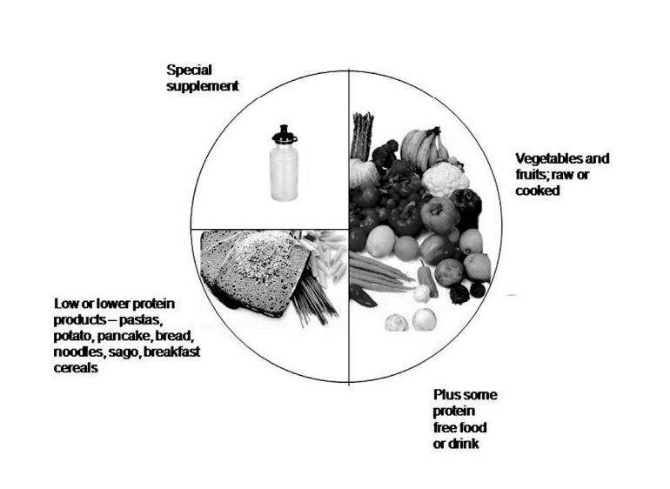
You will need to count and measure the amount of protein that your son is getting every day. The more you do it, the more comfortable you will be and not have to measure everything. Also, make sure to spread the protein throughout the day instead of all in one meal. Below are meal plans for your son throughout his lifetime.
Meal Plan for Toddlers to 12:
Meal | Examples (Found on msud-support.org ) | Protein (g) | Leucine (mg) | Calories
Breakfast | Master Mix Pancakes | 1 | 73 | 116
Lunch | Jordan’s Chili | 1.5 | 60 | 202
Dinner | Barbeque Sandwiches with BBQ Green Beans | 3 | 160 | 220
Snack | Apple Dumpling with syrup | .53 | 39 | 581
Total |  | 6.03 | 332 | 1119

Meal Plan for Teens to Adulthood:
Meal | Examples (Found on mdda.org )
Breakfast | Santa’s Smoothie
Lunch | Vegetable Chow Mein
Dinner | Vegetable Lasagna
Snack | Sweet Potato Pie

References Part 3
Apple Dumplings. (n.d.). Retrieved November 14, 2020, from http://www.msud-support.org/diet-wise/87-general-meals/343-apple-dumplings
Barbeque Sandwiches. (n.d.). Retrieved November 14, 2020, from http://www.msud-support.org/diet-wise/87-general-meals/413-barbeque-sandwiches
Jordan's Chili. (n.d.). Retrieved November 14, 2020, from http://www.msud-support.org/diet-wise/87-general-meals/473-jordans-chili
Ketonex®-1. (n.d.). Retrieved November 14, 2020, from https://abbottnutrition.com/ketonex-1
Maple syrup urine disease. (n.d.). Retrieved November 14, 2020, from https://www.mdda.org.au/diagnosis/msud/
Master Mix Pancakes. (n.d.). Retrieved November 14, 2020, from http://www.msud-support.org/diet-wise/87-general-meals/474-master-mix-pancakes
User, M. (2016, July 18). Santa's Smoothie. Retrieved November 14, 2020, from https://www.mdda.org.au/recipes/santas-smoothie/
User, M. (2016, July 19). Sweet Potato Pie. Retrieved November 14, 2020, from https://www.mdda.org.au/recipes/sweet-potato-pie/
User, M. (2016, July 19). Vegetable Chow Mein. Retrieved November 14, 2020, from https://www.mdda.org.au/recipes/vegetable-chow-mein/
User, M. (2016, July 19). Vegetable Lasagna. Retrieved November 14, 2020, from https://www.mdda.org.au/recipes/vegetable-lasagne/
Zimmerman, W. (n.d.). BBQ Green Beans. Retrieved November 14, 2020, from http://www.msud-support.org/diet-wise/87-general-meals/450-bbq-green-beans

