Project 1: Children’s Hospital 7-Day Menu
Chanley Ferguson
University of Houston

7-Day Menu: Overview

For Project 1 of Commercial Food Production I have created a 7-day menu for a children’s hospital. This menu includes breakfast, lunch, and dinner for Sunday thru Saturday. In order to keep the menu diverse, I have included a vegan protein option and a gluten free starch option for every course. This is to ensure that children of all diets can enjoy this menu. I created the menu to include a variety of colors, culture, and nutrients. This menu can either be served in a cafeteria type setting or as a “room service” that the children can call to their rooms. I kept in mind that this is a menu for children, so I was trying to keep it as child friendly as possible. I wanted to make sure that the food was fun but also safe so many of the vegetable and fruit options are sliced. Throughout the menu, I kept in mind what children would enjoy, since many of them are picky eaters. I also kept in mind that this menu with not only be enjoyed by children, but teenagers as well. All the food items are easy to find at local food markets, such as HEB and Walmart, but they can also be ordered from a food vendor as well if needed. In all, I found this project to be very challenging, especially since this is the first time, I have created a menu for anyone other than myself. However, throughout this project, it was a great learning experience for myself, and is showing me a glimpse of what is yet to come with my nutrition degree.

Sunday
 | REGULAR | Portion | Dietary Info | Calories
B | Breakfast Taco: Egg & Bacon | 4 oz |  | 262
R | Breakfast Taco: Tofu Egg & Veggie | 4 oz | VG | 120
E | with Flour Tortilla | 1 pc |  | 140
A | with GF Tortilla | 1 pc | GF | 130
K
F | Salsa | #30 scoop |  | 10
A | Orange Juice | 1/2 cup |  | 56
S | 2% Milk | 1 carton |  | 122
T | Water | 1 cup |  | 0
 |  |  | Total: | 590
 | Chicken Salad | #8 scoop |  | 231
 | Chickpea Salad | #8 scoop | VG | 224
 | with White Bread | 2 slices |  | 160
L | with GF Bread | 2 slices | GF | 152
U | Carrot Sticks | #8 scoop |  | 50
N | Steamed Broccoli | #8 scoop |  | 17
C
H | Sliced Strawberries | #8 scoop |  | 24
 | Ranch Dip | #30 scoop |  | 100
 | Iced Tea | 1 cup |  | 0
 |  |  | Total: | 582
 | Personal Pizza: Pepperoni & Cheese | 4 oz |  | 239
 | Personal Pizza: Chickpea & Veggie | 4 oz | VG | 230
D | with White Pizza Crust | 1 crust |  | 170
I | with Gluten Free Pizza Crust | 1 crust | GF | 230
N | Garden Salad | #8 scoop |  | 80
N | Grilled Eggplant | #8 scoop |  | 40
E
R | Chocolate Chip Cookie | 1 cookie |  | 120
 | Ranch Dressing | #30 scoop |  | 110
 | Water | 1 cup |  | 0
 |  |  | Total: | 750
 |  |  | Daily Total: | 1,815

Monday
 | REGULAR | Portion | Dietary Info | Calories
 | Pancakes | 2 pancakes |  | 247
B | with Syrup | 1 pc |  | 150
R | GF Pancakes | 2 pancakes | GF | 208
E | with Syrup | 1 pc |  | 150
A | Bacon | 4 oz |  | 75
K | Beyond Meat Breakfast Sausage | 4 oz |  | 360
F | Apple Juice | 1/2 cup |  | 58
A | 2% Milk | 1 carton |  | 122
S | Water | 1 cup |  | 0
T | Margarine | 1 pc |  | 50
 |  |  | Total: | 715
 | Wrap: Turkey & Cheese | 4 oz |  | 180
 | Wrap: Hummus & Veggie | 4 oz | VG | 115
 | with Flour Tortilla | 1 tortilla |  | 140
 | with GF Tortilla | 1 tortilla | GF | 130
L | Celery Sticks | 1/2 cup |  | 8
U | Sautéed Squash | #8 scoop |  | 39
N
C | Grapes: Green & Red | #8 scoop |  | 31
H | Peanut Butter | #30 scoop |  | 180
 | Water | 1 cup |  | 0
 |  |  | Total: | 578
 | Oven Fried Chicken Strips | 4 oz. |  | 330
 | Oven Fried Tempe Strips | 4 oz. | VG | 420
 | Steamed Carrots | #8 scoop |  | 48
 | Halved Cherry tomatoes | #8 scoop |  | 13
D
I | Roll | 1 pc |  | 78
N | GF Roll | 1 pc | GF | 80
N | Chocolate Brownie | 1 pc |  | 182
E
R | Ketchup | 1 pc |  | 17
 | Iced Tea | 1 cup |  | 0
 |  |  | Total: | 668
 |  |  | Daily Total: | 1,961

Tuesday
 | REGULAR | Portion | Dietary Info | Calories
 | French Toast | 2 slices |  | 190
B | GF French Toast | 2 slices | GF | 288
R | with Syrup | 1 pc |  | 150
E | Scrambled eggs | #8 scoop |  | 182
A | Tofu Scrambled Eggs | #8 scoop | VG | 80
K | Sliced Kiwi | #8 scoop |  | 54
F
A | Fat Free Chocolate Milk | 1 carton |  | 120
S | Water | 1 cup |  | 0
T | Margarine | 1 pc |  | 50
 |  |  | Total: | 746
 | Ham & Cheese Sandwich | 4 oz |  | 140
 | PB&J Sandwich | 4 oz | VG | 300
 | with White Bread | 2 slices |  | 160
L | with GF Bread | 2 slices | GF | 152
U | Cucumber Slices | #8 scoop |  | 10
N | Roasted Broccoli | #8 scoop |  | 20
C
H | Raspberries | #8 scoop |  | 40
 | Ranch Dip | #30 scoop |  | 100
 | Iced Tea | 1 cup |  | 0
 |  |  | Total: | 470
 | Taco: Beef & Cheese | 4 oz. |  | 257
 | Taco: Black Bean & Veggie | 4 oz. | VG | 244
D | with Flour Tortilla | 1 pc |  | 140
I | with Corn Tortilla | 1 pc | GF | 58
N | Sautéed Peppers & Onions | #8 scoop |  | 37
N | Cold Corn & Tomato Salad | #8 scoop |  | 143
E
R | Vanilla Pudding | #8 scoop |  | 90
 | Sour Cream | #30 scoop |  | 10
 | Crystal Light | 1 cup |  | 10
 |  |  | Total: | 687
 |  |  | Daily Total: | 1,903

Wednesday
 | REGULAR | Portion | Dietary Info | Calories
B | Potato Egg Scramble | 4 oz. |  | 260
R | Potato Tofu Scramble | 4 oz. | VG | 374
E | White Toast | 1 slice |  | 80
A | GF Toast | 1 slice | GF | 76
K | Sliced Strawberries | #8 scoop |  | 40
F | Strawberry Fat Free Milk | 1 carton |  | 130
A | Water | 1 cup |  | 0
S | Margarine | 1 pc |  | 50
T |  |  | Total: | 560
 | Baked Chicken Nuggets | 4 oz |  | 385
 | Baked Tofu Nuggets | 4 oz. | VG | 266
 | Grilled Tomatoes | #8 scoop |  | 20
L | Snap Peas | #8 scoop |  | 20
U | Mashed Potatoes | #8 scoop | GF | 150
N | Orange Slices | #8 scoop |  | 42
C
H | Ketchup | 1 pc |  | 15
 | Iced Tea | 1 cup |  | 0
 |  |  | Total: | 632
 | Cheeseburger | 4 oz. |  | 350
 | Black Bean Burger | 1/2 cup | VG | 138
D | with White Bun | 1/2 cup |  | 120
I | with GF Bun |  | GF | 200
N | Carrot & Cabbage Slaw | #8 scoop |  | 88
N | Baked Sweet Potato Fries | #8 scoop |  | 152
E
R | Rice Krispy Treat | 1 pc |  | 45
 | Ketchup | 1 pc |  | 17
 | Crystal Light Lemonade | 1 cup |  | 15
 |  |  | Total: | 787
 |  |  | Daily Total: | 1,979

Thursday
 | REGULAR | Portion | Dietary Info | Calories
B | Waffles | 2 slices |  | 332
R | GF Waffles | 2 slices | GF | 277
E | with Syrup | 1 pc |  | 150
A | Scrambled Eggs | #8 scoop |  | 182
K | Tofu Scrambled Eggs | #8 scoop | VG | 80
F | Sliced Apples | #8 scoop |  | 54
A | Fat Free Chocolate Milk | 1 carton |  | 120
S | Water | 1 cup |  | 0
T | Margarine | 1 pc |  | 50
 |  |  | Total: | 888
 | Quesadilla: Steak & Cheese | 4 oz |  | 300
 | Quesadilla: Black Bean & Veggie | 4 oz. |  | 244
 | with Flour Tortilla | 1 pc |  | 140
L | with GF Tortilla | 1 pc | GF | 130
U | Corn | #8 scoop |  | 60
N | Sliced Bell Pepper | #8 scoop |  | 9
C | Blueberries | #8 scoop |  | 42
H | Salsa | #30 scoop |  | 10
 | Iced Tea | 1 cup |  | 0
 |  |  | Total: | 561
 | Teriyaki Chicken | 4 oz. |  | 258
 | Teriyaki Tofu | 4 oz. | VG | 198
D | Jasmine Rice | #8 scoop | GF | 103
I
N | Roasted Broccoli | #8 scoop |  | 20
N | Ribbon Carrots | #8 scoop |  | 50
E
R | M&M Cookie | 1 pc |  | 81
 | Soy Sauce | 1 pc |  | 5
 | Fruit Punch Crystal Light | 1 cup |  | 15
 |  |  | Total: | 532
 |  |  | Daily Total: | 1,981

Friday
 | REGULAR | Portion | Dietary Info | Calories
B | English Muffin | 1 pc |  | 150
R | GF English Muffin | 1 pc | GF | 180
E | Breakfast Sausage | 4 oz. |  | 380
A | Beyond Meat Breakfast Sausage | 4 oz. | VG | 360
K
F | Orange Juice | 1/2 cup |  | 56
A | Chocolate Fat Free Milk | 1 carton |  | 120
S | Water | 1 cup |  | 0
T | Sugar Free Grape Jam | 1 pc |  | 10
 |  |  | Total: | 716
 | Wrap: Chicken & Cheese | 4 oz. |  | 180
 | Wrap: Hummus & Veggie | 4 oz. | VG | 115
 | with Flour Tortilla | 1 pc |  | 140
L | with GF Tortilla | 1 pc | GF | 130
U
N | Fresh Broccoli | #8 scoop |  | 20
C | Sautéed Squash | #8 scoop |  | 39
H
 | Sliced Strawberries | #8 scoop |  | 40
 | Ranch Dip | #30 scoop |  | 100
 | Iced Tea | 1 cup |  | 0
 |  |  | Total: | 519
 | Turkey Chili | 4 oz. |  | 185
 | Bean Chili | 4 oz. | VG | 202
 | Side Salad | 1/2 cup |  | 80
 | Roasted Cauliflower | 1/2 cup |  | 15
D
I | Corn Bread | 1 pc |  | 120
N | GF Corn Bread | 1 pc | GF | 140
N
E | Vanilla Pudding | #8 scoop |  | 90
R | Ranch Dressing | #30 scoop |  | 110
 | Margarine | 1 pc |  | 50
 | Iced Tea | 1 cup |  | 0
 |  |  | Total: | 650
 |  |  | Daily Total: | 1,885

Saturday
 | REGULAR | Portion | Dietary Info | Calories
B | Vanilla Greek Yogurt | 4 oz |  | 140
R | Vanilla Soy Yogurt | 4 oz | VG | 140
E | Cheerios | #8 scoop | GF | 130
A | Frosted Flakes | #8 scoop |  | 220
K
F | Sliced Strawberry & Banana | #8 scoop |  | 80
A | 2% Milk | 1 carton |  | 122
S | Water | 1 cup |  | 0
T |  |  | Total: | 562
 | Turkey & Cheese Sandwich | 4 oz |  | 140
 | PB&J Sandwich | 4 oz | VG | 300
 | with White Bread | 2 slices |  | 160
L | with GF Bread | 2 slices | GF | 152
U | Carrot Sticks | #8 scoop |  | 50
N | Roasted Cauliflower | #8 scoop |  | 15
C
H | Watermelon | #8 scoop |  | 20
 | Ranch Dip | #30 scoop |  | 100
 | Iced Tea | 1 cup
 |  |  | Total: | 485
 | Turkey Meatballs | 4 oz. |  | 250
 | Vegan Meatballs | 4 oz. | VG | 202
 | with Tomato Sauce | #16 scoop |  | 60
 | Rotini Pasta | #16 scoop |  | 200
D | Lentil Rotini Pasta | #16 scoop | GF | 180
I | Caesar Salad | #8 scoop |  | 80
N | Grilled Eggplant | #8 scoop |  | 40
N
E | Lemon pudding | #8 scoop |  | 90
R
 | Caesar Dressing | 1 pc |  | 120
 | Iced Tea | 1 cup |  | 0
 |  |  | Total: | 840
 |  |  | Daily Total: | 1,887

3-Day Analysis: Cronometer-SUNDAY
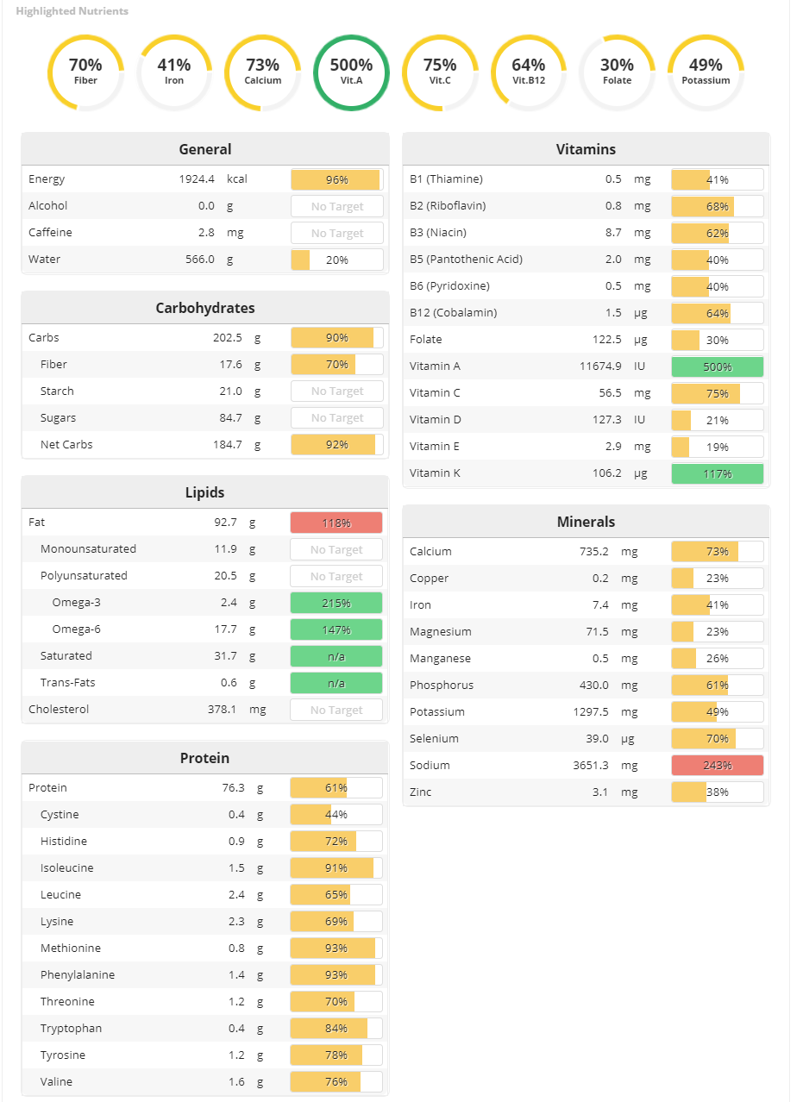
3-Day Analysis: Cronometer-MONDAY
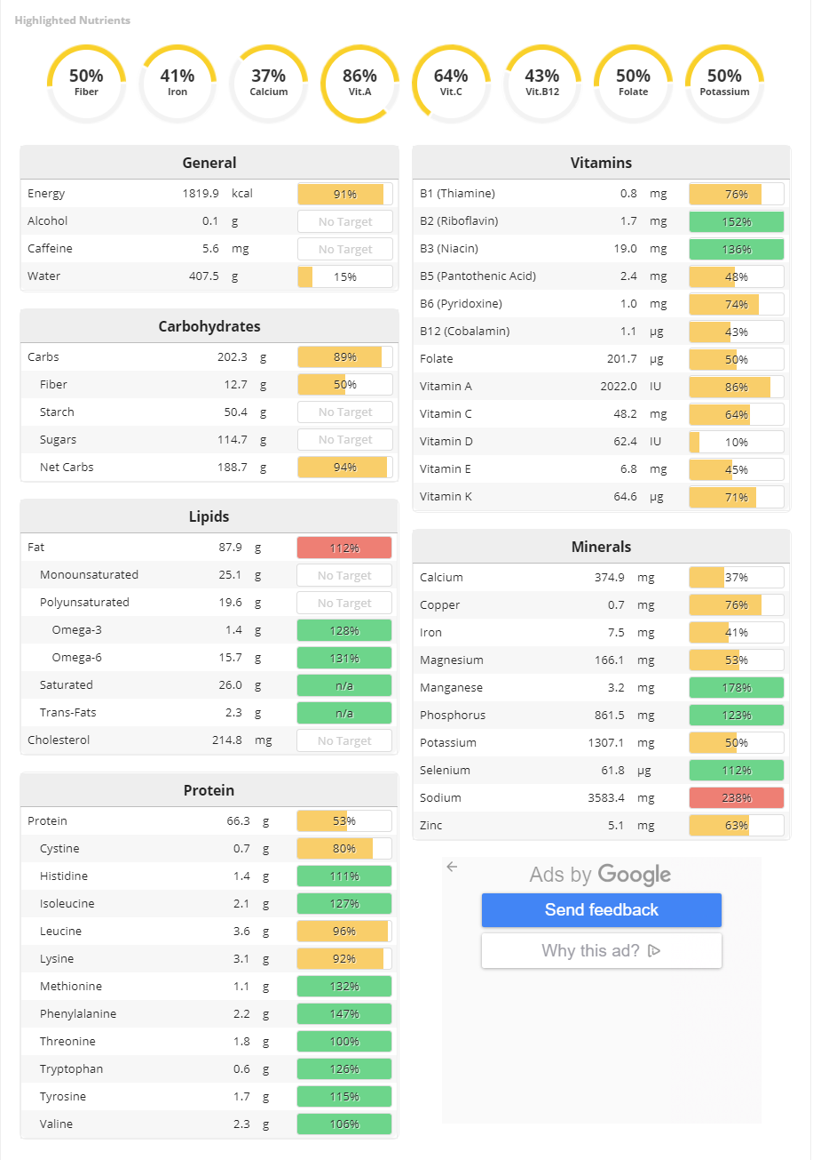
3-Day Analysis: Cronometer-TUESDAY
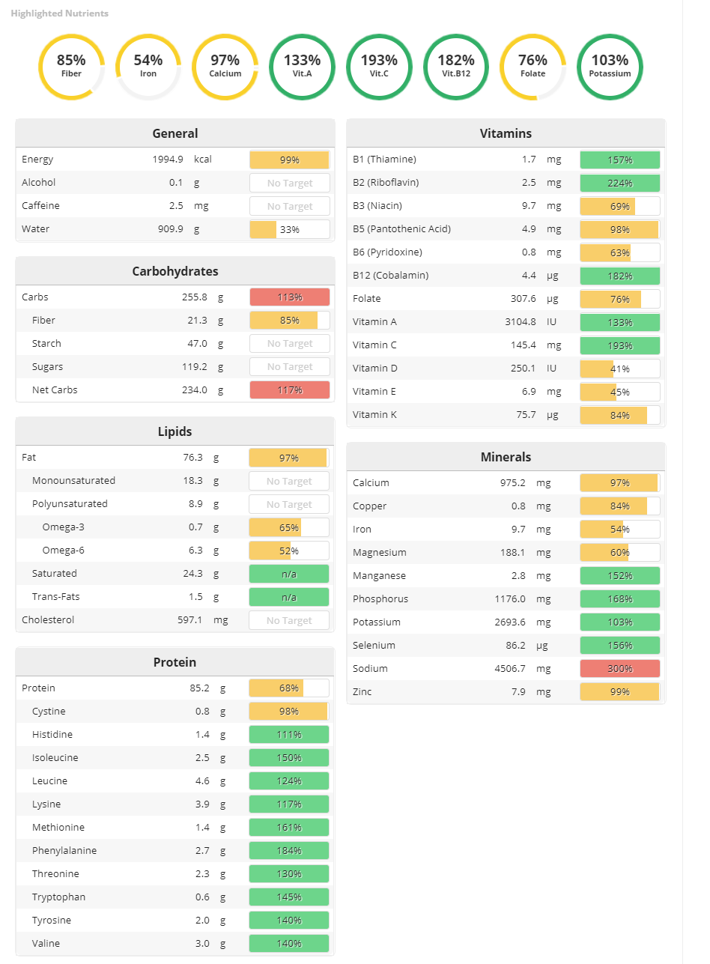
3-Day Analysis: Cronometer-Average
Calories: | 1,913 kcal
Protein: | 75.9 g
Carbohydrate: | 220.2 g
Fat: | 85.6 g
Saturated Fats: | 27.3 g
Cholesterol: | 396.7 g
Fiber: | 17.2 g
Sodium: | 3,913.8 mg
Iron: | 8.2 mg
Vitamin C: | 83.4 mg
Vitamin A: | 5,600.6 IU

References:
A. (2003). Best Brownies. Retrieved September 26, 2020, from https://www.allrecipes.com/recipe/10549/best-brownies/
A. (2020, April 02). Easy Vegan Black Bean Burgers. Retrieved September 26, 2020, from https://www.hummusapien.com/easy-vegan-black-bean-burgers/
A. (2020, April 05). Black Bean Taco Filling (vegan, gluten-free). Retrieved September 26, 2020, from https://www.runningwithspoons.com/black-bean-taco-filling/
Ackerman, R. (n.d.). Oven-Baked Sweet Potato Fries. Retrieved September 26, 2020, from https://www.allrecipes.com/recipe/273103/oven-baked-sweet-potato-fries/
Baker, M. (2020, August 21). The Best Vegan Meatballs: Minimalist Baker Recipes. Retrieved September 26, 2020, from https://minimalistbaker.com/the-best-vegan-meatballs/
Carrot Ribbon Salad. (n.d.). Retrieved September 26, 2020, from https://www.bhg.com/recipe/carrot-ribbon-salad-1/
Easy French Toast Recipe. (n.d.). Retrieved September 26, 2020, from https://www.mccormick.com/recipes/breakfast-brunch/quick-and-easy-french-toast?utm_source=GoogleAds
Fuentes, L. (2020, September 03). THE Best Gluten Free Pancakes (No Lie). Retrieved September 26, 2020, from https://www.laurafuentes.com/easy-gluten-free-pancake-recipe/
Gruss, T. (2019). Heavenly Gluten-Free French Toast With Coconut Milk. Retrieved September 26, 2020, from https://www.thespruceeats.com/gluten-free-french-toast-recipe-1450918
Holt, S. (2006). Easy Pancakes. Retrieved September 26, 2020, from https://www.allrecipes.com/recipe/45396/easy-pancakes/
Ingraham, A. (2006). Simple Turkey Chili. Retrieved September 26, 2020, from https://www.allrecipes.com/recipe/80969/simple-turkey-chili/
J. (2020, August 30). Teriyaki Chicken {Easy 15 Minute Recipe}. Retrieved September 26, 2020, from https://www.cookingclassy.com/teriyaki-chicken/
Kitchen, F. (2013, November 21). Tofu-Potato Scramble. Retrieved September 26, 2020, from https://www.foodnetwork.com/recipes/food-network-kitchen/tofu-potato-scramble-recipe-2106815
Kitchens, B. (2010, August 19). Potato, Bacon and Egg Scramble. Retrieved September 26, 2020, from https://www.bettycrocker.com/recipes/potato-bacon-and-egg-scramble/5ff56a80-772e-4882-b394-2c605d9ebdae
Kitchens, B. (2020, February 24). Ultimate Chocolate Chip Cookies. Retrieved September 26, 2020, from https://www.bettycrocker.com/recipes/ultimate-chocolate-chip-cookies/77c14e03-d8b0-4844-846d-f19304f61c57
Kitchens, B. (2020, September 07). Oven-Fried Chicken Tenders. Retrieved September 26, 2020, from https://www.bettycrocker.com/recipes/oven-fried-chicken-tenders/46a69e4d-4c31-485b-9d43-67d40b353f2e
Lofthouse, H. (2019, June 18). Easy Turkey Meatballs. Retrieved September 26, 2020, from https://www.pillsbury.com/recipes/easy-turkey-meatballs/d36740f4-f885-415c-8b13-2ae945b57086
Madormo, C. (2020, April 23). This Easy Coleslaw Recipe Belongs in Your Recipe Box. Retrieved September 26, 2020, from https://www.tasteofhome.com/article/easy-coleslaw-recipe/
Monkey, P. (2004, September 14). Yellow Squash Saute. Retrieved September 26, 2020, from https://www.food.com/recipe/yellow-squash-saute-99815
O. (n.d.). Waffles I. Retrieved September 26, 2020, from https://www.allrecipes.com/recipe/22180/waffles-i/
Octarima, B., Crocker, B., & Kuhlmann, J. (2010, April 01). Baked chicken nuggets. Retrieved September 26, 2020, from http://allrecipes.co.uk/recipe/6760/baked-chicken-nuggets.aspx
R. (2013). Easy Bean Chili. Retrieved September 26, 2020, from https://www.readyseteat.com/recipes-Easy-Bean-Chili-6480
Recipe: Veggie and Tofu Scramble. (2014, May 05). Retrieved September 26, 2020, from https://www.wholefoodsmarket.com/recipes/veggie-and-tofu-scramble
Robles, L., Parsons, K., & Taylor, T. (2020, May 19). Tofu Scramble. Retrieved September 26, 2020, from https://simpleveganblog.com/simple-tofu-scramble/
S. (2008, May 16). Marinated Teriyaki Tofu. Retrieved September 26, 2020, from https://www.food.com/recipe/marinated-teriyaki-tofu-303786
S. (2014). Gluten-Free Waffles. Retrieved September 26, 2020, from https://www.allrecipes.com/recipe/239606/gluten-free-waffles/
Savory Chicken Salad. (n.d.). Retrieved September 26, 2020, from https://www.mccormick.com/recipes/main-dishes/savory-chicken-salad
Schultze, R. (2005). Robbi's M&Ms® Cookies. Retrieved September 26, 2020, from https://www.allrecipes.com/recipe/10785/robbis-mms-cookies/
Smith, D., & Andres, N. (2020, June 19). Corn, Tomato Salad. Retrieved September 26, 2020, from https://www.plantbasedcooking.com/recipe/corn-tomato-salad/
Steffens, M. (2020). Hummus & Veggie Wrap-Up. Retrieved September 26, 2020, from https://www.tasteofhome.com/recipes/hummus-veggie-wrap-up/
Thomson, L. (2019, June 05). Crispy Tempeh Strips. Retrieved September 26, 2020, from https://iheartvegetables.com/crispy-tempeh-strips-2/

