

General Symptoms:
Symptoms vary per person but will most likely have similar symptoms from episode to episode. It also depends on what portion of the brain is being affected.
- Uncontrollable jerking or twitching movements of the arms and legs
- Loss of consciousness or awareness
- Temporary confusion
- A staring spell
- Psychic symptoms
  - Fear
  - Anxiety
  - Déjà vu
- Head drops or fall.

Information Technology Solutions

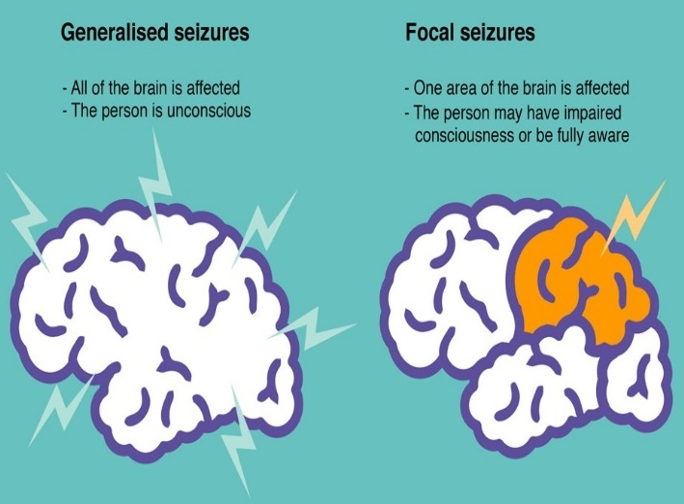
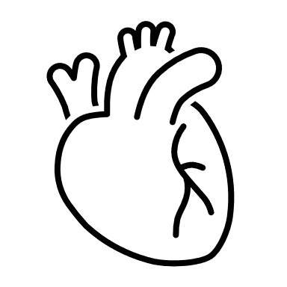
What is it?
Epilepsy is a chronic neurological disorder where brain electrical activity is disrupted and becomes abnormal. This disruption causes seizures or periods of unusual behavior, sensations and possibly loss of awareness which can last from a few seconds to several minutes. In order to be fully diagnosed, a person has to have 2 or more seizures.
There are 2 types of seizures:
- Focal Seizures (2): Only in one area (lobe) of the brain.
  - Without loss of consciousness
  - With impaired awareness or consciousness
- Generalized Seizures (6): The entire brain is affected.
  - Absence- staring into space.
  - Tonic- stiffening of muscles
  - Atonic- loss of muscle control
  - Clonic- jerking muscle movements
  - Myoclonic- twitching of the arms and legs
  - Tonic-clonic- stiffening and shaking of the body, can result in loss of consciousness.

- Taking antiepileptic drugs (AEDs)
- Surgical Interventions
- Follow the Ketogenic Diet
  - High intake of:
    - Oils
    - High-Fat Dairy
    - Meats
    - Berries
    - Above-Ground Vegetables
  - Low intake of:
    - Grains
    - Sugar
    - Fruit
    - Starchy Vegetables

How to fix/prevent it?
Who is at Risk?__
- Children and older adults
- Family history of epilepsy
- Head injuries
- Vascular diseases or strokes
- Developmental disorders (autism)
- Drug and alcohol abuse
- Infections of the brain
- Women are more at risk than males.

Image adapted from Seizure types | Epileptic seizures | Guide for schools (youngepilepsy.org.uk)
Epilepsy

References:
Centers for Disease Control and Prevention. (2020, September 30). About Epilepsy. Centers for Disease Control and Prevention. https://www.cdc.gov/epilepsy/about/index.htm
Epilepsy Foundation. (n.d.). https://www.epilepsy.com/
Mayo Foundation for Medical Education and Research. (2021, March 31). Epilepsy. Mayo Clinic. https://www.mayoclinic.org/diseases-conditions/epilepsy/symptoms-causes/syc-20350093
Seizure types: Epileptic seizures: Guide for schools. Young Epilepsy. (n.d.). https://www.youngepilepsy.org.uk/guide-for-schools/epileptic-seizures/seizure-types/

